Name:

ID:

Submit here: <https://docs.google.com/forms/d/e/1FAIpQLSfAH2GS0lBdrdVJlOxV9rrVajqnGcQ8-DL-kNtIfiQ-ryaK8Q/viewform>

Challenge 07

PART 2: [Functions](https://runestone.academy/runestone/books/published/fopp/Functions/intro-Functions.html)

1. Consider the following:

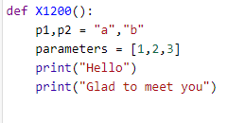

* How many parameters does this function have?

|  |  |
| --- | --- |
| 0 | 1 |
| 2 | 3 |
| 4 | 5 |

1. Which of the following is not a legal name for a function?

|  |  |
| --- | --- |
| variable | name |
| function | _0 |
| Func1 | 1Func |

1. Consider the following function?

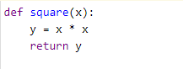

* How can I change the square function so that it returns a number cubed?

|  |  |
| --- | --- |
| Change the name from square to cube | It already returns a cube |
| y=x*x+x | y=x + x+ x+x |
| y=x**2 | y=x *x*x |

1. Which of the following best describes the function G:

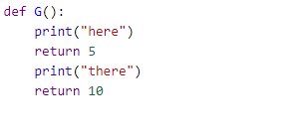

|  |  |
| --- | --- |
| Always return 10 | Returns 5 sometimes and 10 sometimes |
| Always returns 5 | Returns 10 more than it returns 5 |
| Returns: here, there | Returns: here, there, 5, 10 |

Part 2: Challenge problems

1. Consider the following:

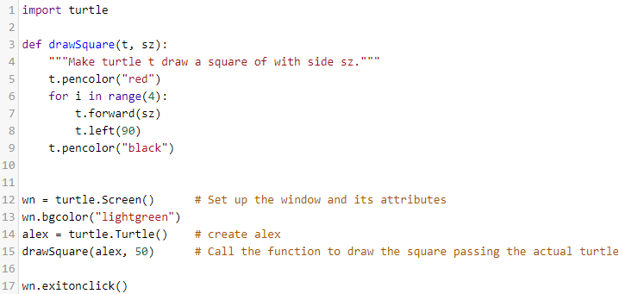

* The drawSquare function creates a red square. Create a function named “drawTriangle” that creates an orange equilateral triangle. Paste a screenshot of your triangle and your code below:

2. Consider the following formulas:

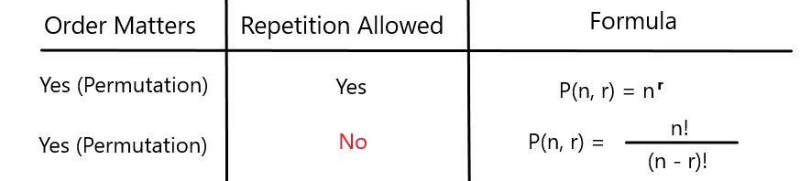

S = {A,B,C}

A permutation is a sequence of elements, in which order matters. There are two types:

1. Repetitions allowed – P(3,2) =9 permutations: AA, AB, AC, BB, BA, BC, CC, CA, CB

2. Repetitions not allowed – P(3,2) = 6 permutations: AB, AC, BA, BC, CA, CB

The factorial function:

n! = n * (n-1) * … * 2 * 1

Examples:

3! = 3*2*1 = 6

5! = 5*4*3*2*1 = 120

* Write code for the factorial function, paste below:
* Complete the following table:

|  |  |
| --- | --- |
| n | n! |
| 78 |  |
| 243 |  |

* Consider the following set, representing people waiting in a line. How many different ways could these people be waiting in line?

S = {“Tom”,”Nick”,”Frank”,”Chris”}

|  |  |
| --- | --- |
| 64 | 16 |
| 8 | 24 |
| 100 | 256 |
| 1 | 4 |

* Consider a mobile banking application that wants you to create a 4-digit pin code consisting of the number 0-9. How many different pin codes exist?

|  |  |
| --- | --- |
| 6048 | 3024 |
| 15120 | 6561 |
| 9 | 60056 |
| 36 | 729 |

* How would you describe the growth of the factorial function?